**Git Hub**

***************

**SLA** :- Service level agreement

1. ***srs*** *:* software requirement specification

*or known as urs :* user requirement specification.

1. Taxation, Invoicing
2. Terms and conditions
3. security ---> followed by security Audit and verification.

*Software Ready*

Security Audit ---> Task ---> Resolve----> developer (30 days) salary : 30000/- 10 days => 10000/-

this problem, is not only related to, security audit, but during coding and desiging cycle.

# Introduction to git:-

******************

1. git unix|linux based tool for scm (source code management)

or vcs(version control system)

***version***: next type or upgraded type version here means changes in source code.

*********************************************

git vs github

******************************************

1. command line tool | cloud
2. local system server
3. code manage code upload, code host
4. Linux Torvald (Linux) microsoft (Bill Gates)

# Tools other than git

svn or tortoise (sub versioning) : centralised

git is distributed.

**Cmd:-**  **<tool-name> <command>**

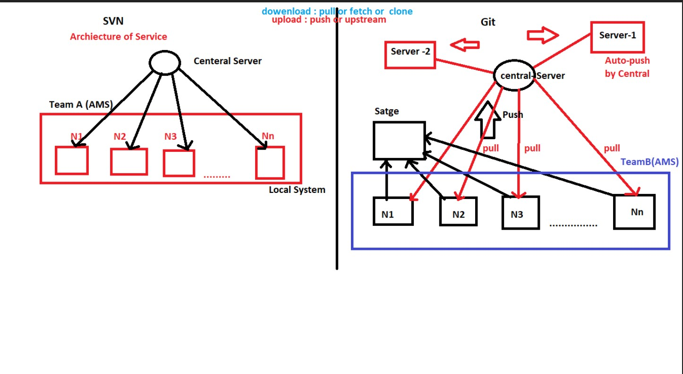

# Tools other than git hub

other than git hub, we have gitlab, bitbucket, bitkeeper

***Important Terms:-***

donwload => pull,fetch,clone upload => push,upstream

**Note ::** In git, pull,fetch,clone are all used to download but in different cases.

# All are same as donwload but at different case

git clone <project>

git pull <project-part>

git fetch –all

[ git clone (shift+insert)]

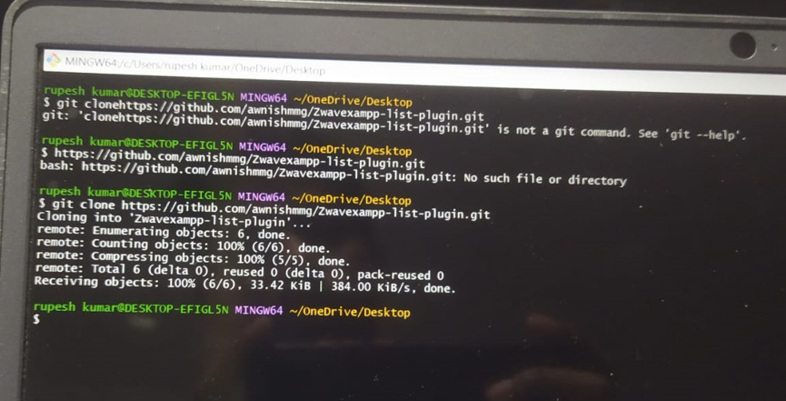

# git flavours:-

flavours means git is available in other forms :-

1. Cli (command line interface | cmd black and white screen) : comamnds
2. GUI (graphical User Interface) | GUI no coding or command Require

fastest : cli

slow : gui *************** secure | cli insecure | gui

***************** beginner | gui

expert |cli

*******************

dev|designer|coder |dba|tester |bde => Technical line => CLI

Repository => project folder

________________________________________________________

# 31-oct-2022

***********

profile Url or Account Url or workspace url or Profile Url

<https://github.com/username/project-name> : Access public https://github.com/username/project-name : If private ----> owner

-----> Login

# Key Points :-

1. *default branch*: master or main changes on August, 2021.

1. If public repo, add valid License if you have if not, Let it be None, or Unlicensed.
2. Public Repository (Repo) can be forked (pull) by anyone (pull).
3. Url, it is visible to Everyone in the Universe.
4. Your Every Action is recorded as Activity and, Added in Watcher list .

**Ques:**

Repo xyz owner vibhu

*Url :-* https://github.com/vibhu/xyz

Requirement Analysis

Design Analysis

Developement

( Design | coding | Database )

Testing

Deployment ( Release) monitoring feedback

Hence, from above discussion it is very clear that git provide complete support from Requirement gathering to feedback cycle. where memeber can contribute there, part.

# 1-nov-2022

## *How to Add members to the Repository*

**************************************************

Members working together in a team for a Repository is called , collabarators .

# Types of Settings :- Github two types --

...............................

1. **Global level setting : -** It is locate on profile menu or Account menu All setting applied here , will be applied on the entire project .
2. **Repo level setting** **: -** Repo setting is located on the right hand

side of the , each private or public repo , everything you create a repo , you need to edit these setting .

**forked –**

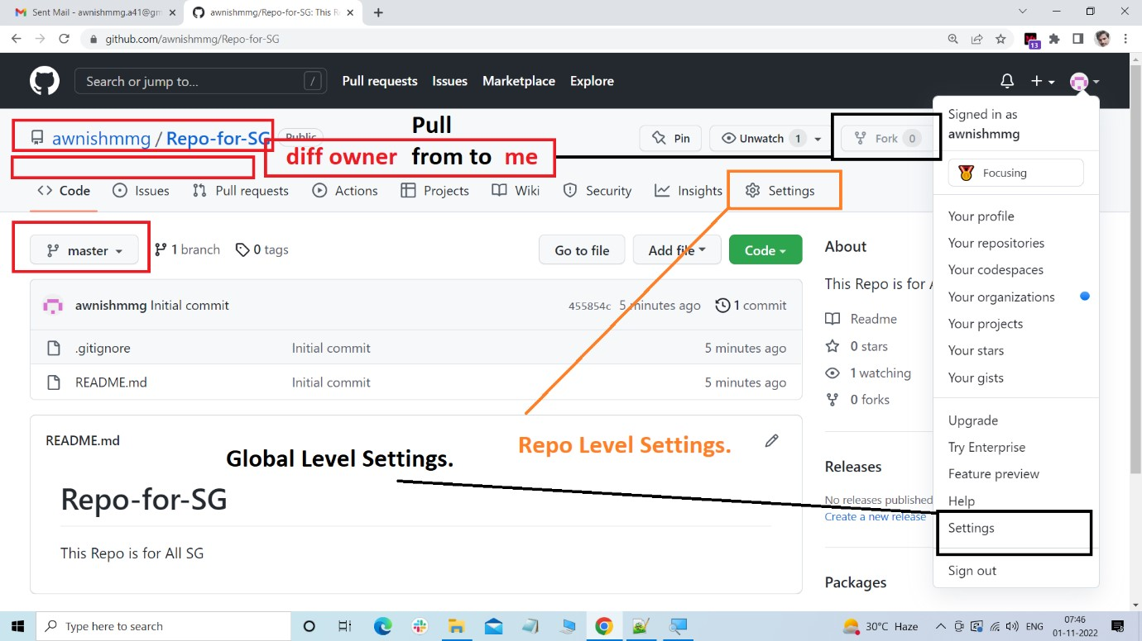

**What is fork How is it important:**

Fork create copy project from different to owner to my account it can be applied on public repo.

**merging-from-origin –**

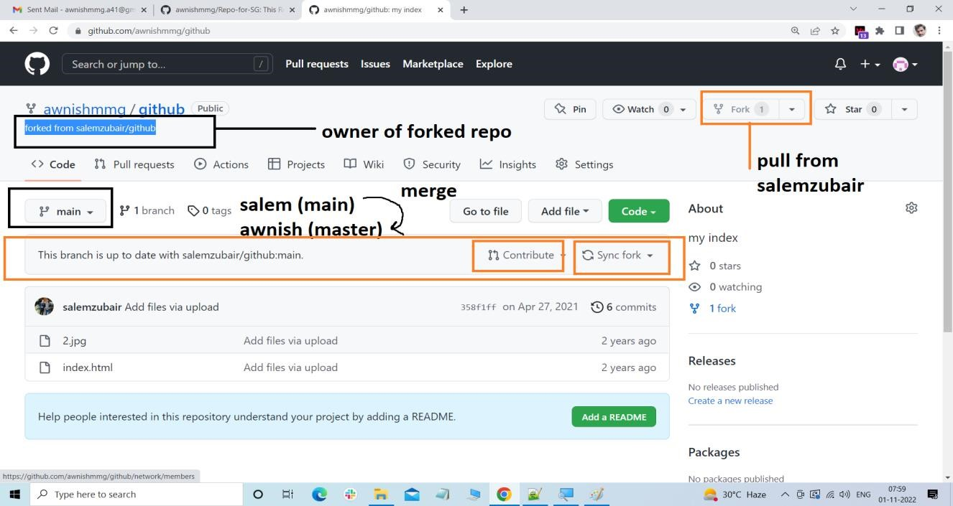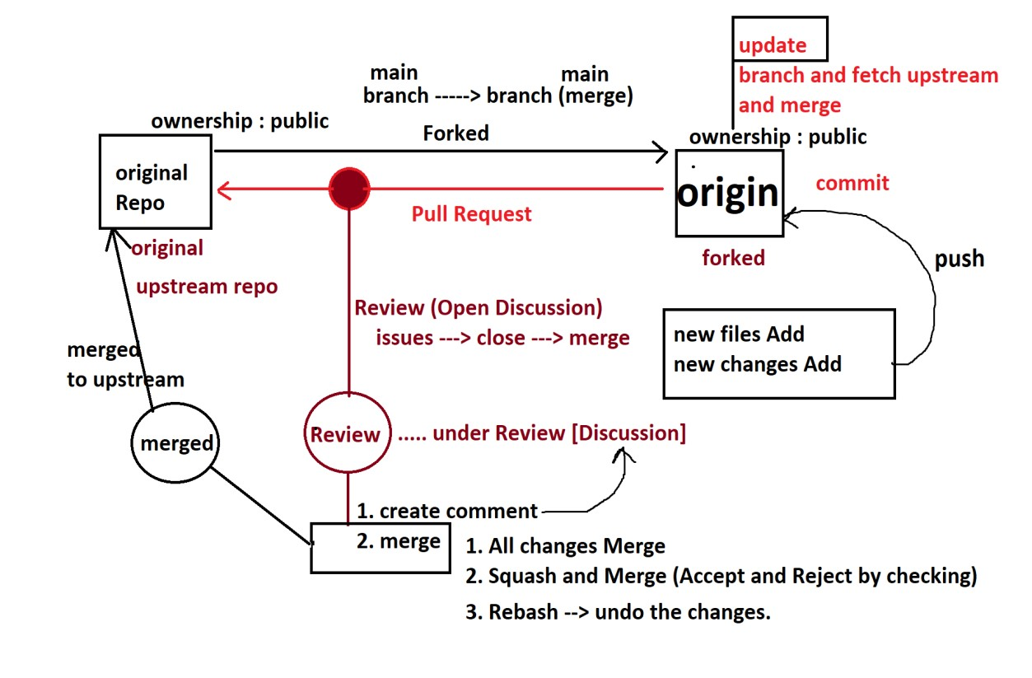

**2-Nov-2022**

# Linux

## working with git in local system

REPL :- Read Evaluate print loop : symbol of the terminal related to any langauge

>>> print('hi')

hi

> print('hi');

syntax error

> console.log('hi') cmd:\> echo hello

hello

**$ :** unix or linux

### Important command of Unix or Linux

1. **whoami :** tell the owner name or pc name
2. **clear :** clear the console
3. **echo :** print the output or expression
4. **dir :** used to list of folder and files <cmd B/W>
5. **ls** : used to list down files and folders <unix terminal colorful>

1. **touch :** used to create empty files with or without extension.
2. **mkdir :** used to create folder(directory)

#### 8. ls -lart

Note :- ./ or . current Directory

../ or .. parent Directory

9. **cd :** to change the path

Eg : $ cd <path-name>

## Types of File and Folder

**************************

1. ***Anonymous File*** : with Extension but no name
2. ***Named File*** : with name and extension or with name without extension.

extension .name => extension

without . name => firstname

file fullname => firstname + extension

**Types of folder:-**

1. *hidden folder :* **.**foldername
2. *without folder* : readable folder

### ls and ls -lart

**ls :** normal files and folder show.

**ls -lart :** all hidden files and folder.

**ls :** no count of files and folder.

**ls -lart :** total no of files and folder.

**ls :** files and folders horizontally display.

**ls -lart :** vertically files and folders.

**ls :** No files permission and meta data.

**ls -lart :** shows all permission, of read, write, execute, security,

sharing. author, when created, who created, data and time

information (meta-data).

**rm will delete file**

rm -r <folder-name> : delete folder (shift + delete)

### Task 1:-

mkdir xyz

|--cd--> abc.txt (touch)

**&& :** multiple statement Run at a single line

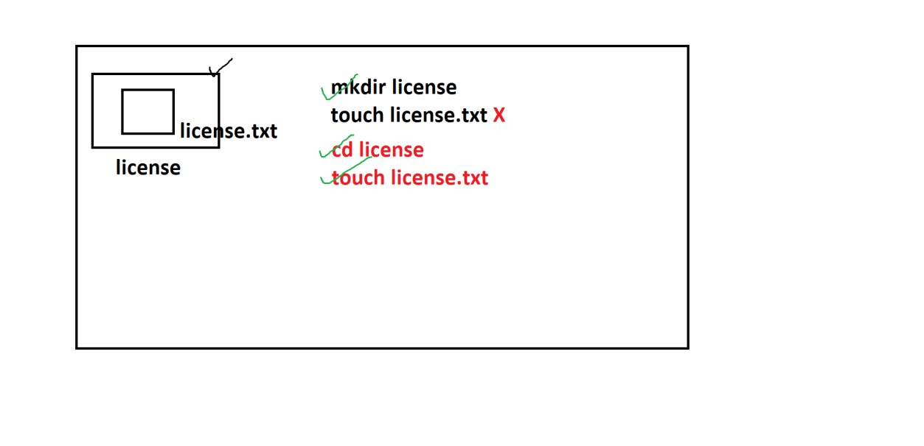

### How to write data inside a file

*******************************

echo any statement you want to write > abc.txt

**How to write data inside a file** ************************** cat <filename>

**eg:**

cat abc.txt

content at

### Task Write the Two lines inside abc.txt file

**************************************

1. echo html is front end langauge > abc.txt
2. echo python is backend langauge > abc.txt

#### *Shell file write two mode*

1. overide mode >
2. append mode >>

### How to set Range in command

****************************** $ command anyname{start..end}

**eg:**

make 300 folders

mkdir test{1..300}

delete 300 folder

rm -r test{1..300}

**pwd :-** print working directory

display current full path

Before we finish with git, we must be know basic command of linux

| unix.

that we already know.

## Basic Terminology in Git

***********************

### *1. Versioning or version :-*

maintianing the different changes of code is called as versioning or version.

### *2. Work-space / working Directory*

That main folder where we are working , and all our important files and folder are located .

D:

|------------------------> summerTraning

|------------------------> winterTRaning

|------------------------> Apprenticship

|

|----------------------

1.html

2.css/js/php/Android/

3.projects (work-space/working)

1.calculator

2.static-web sites

3. crud.project

1. **Repository:**

Type 1. *public Repository :* Everyone access

*2. private Repo :* No body can access only access can be

done who has the access.

Access : owership (master|main)

Team :

forked : contributer ---------> for contributer -------> fork life cycle.

we know that github cloud, centralizedd server connected data share.

### Local System

local system

1. Private repo.

### Scope Transfer or Visibility Transfer :-

local Repo visibility : private

private : share own -------> private in github

private : share Team -------> private in github

private : share with Everyone -------> public in github

**Different phases of Files/Floder in the Git**

#### ************************************

1. untracked |
2. tracked |
3. stage |
4. commit |
5. origin |
6. upstream |

Towards Downwards

***we have three repository*** i.) local system

| push

**|**

ii.) your github repo

|

fork/pr (pull req.)

| iii.) others github repo

|

pull or clone or fetch

|

|

iv.) others local system

## Repository :-

*************

Sauhar( Pati ) ----------------------------------> Abbu (papa)

min 1 child

*Parent* : workspace / working directory

**Workspace –**

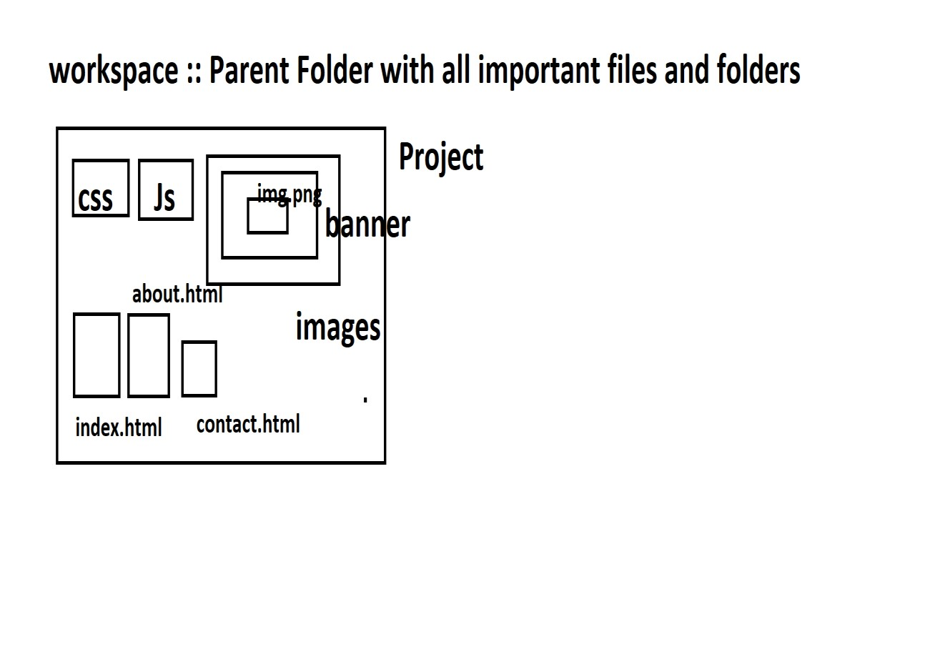

+------------------+

| Folder 1 |

| Folder 2 | -------------------------> Repository

| Folder 3 | special folder (.git)

| Folder 4 | atleast/minimun one commit (initial commit).

| Folder-n |

+-------------------+

**Commit –**

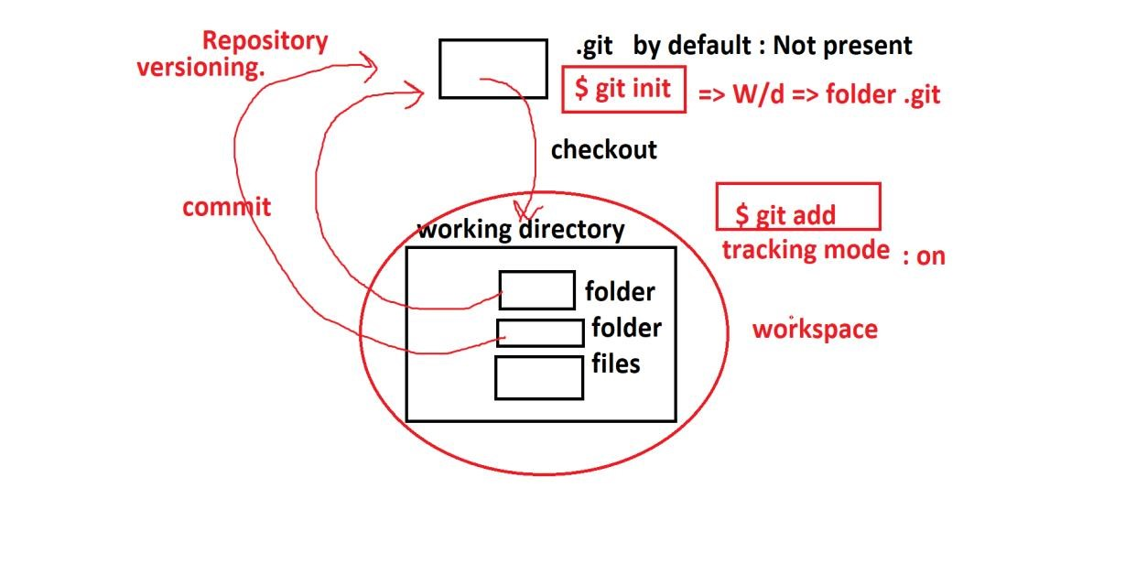

1. **commit :-** means save ,add the file to the .git repository
2. **checkout :-** taking back the files from .git to the original workspace or working directory is called as , checkout.

**________________________________________________________________**

**4-Nov-2022**

### Git Architecture :-

If you look at SVN architecture, then every commit and checkout.

will take from central repository or server(cloud).

Note :: In svn not data is locally saved.

but in Git data is saved locally as well as in, cloud.

**svn-vs-git-cc-cycle –**

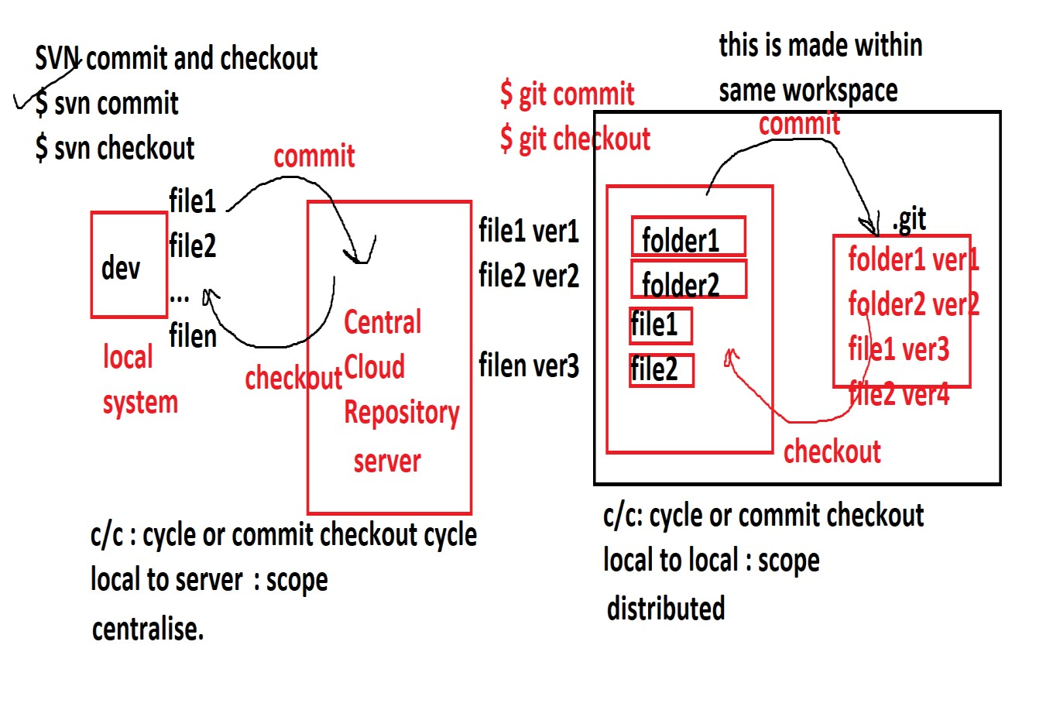

### important command in git:-

$ git status : status check for file .

### How to initialise .git repo

$ ls -lart .git folder not available

$ git init

$ ls -lart .git/

### How to add files to stage (add to cache)

$ git add index.html

**Versioning –**

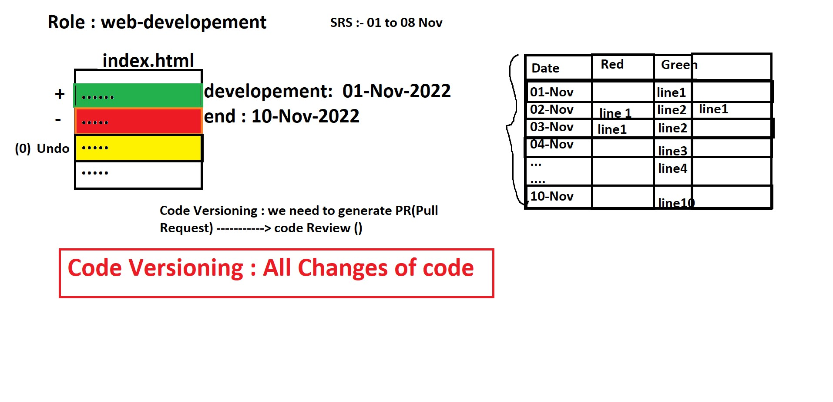

### How to add files to un-stage file (remove from cache)

$ git rm --cached index.html

### How to commit the changes in the file

**Note ::** before commit your git should know you information or

Indentity

This indentity is saved in config

#### How to get author information to config:-

**Note ::** One system has one owner

local config

global config

single user : global

multiple user : local

**How to see local and global config**

$ git config --local

$ git config --global

### Author Information:-

git store author two details :

1. user.name:
2. user.email:

### local Author data see

$ git config --local user.name

$ git config --global user.name

$ git config --local user.email

$ git config --global user.email

### How to set author information to config:-

$ git config --local user.name "soni nishad"

$ git config --local user.email "soninishad7860@gmail.com"

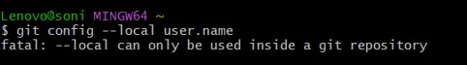

$ git config --global user.name "soni nishad"

$ git config --global user.email "soninishad7860@gmail.com"

#### To see :-

$ git config --global user.name

$ git config --global user.email

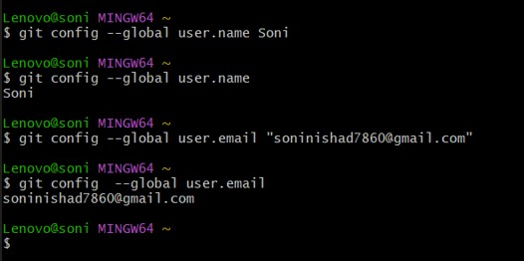

#### How to commit the changes:-

$ git commit -m "I have added index.html and about.html and

some code"

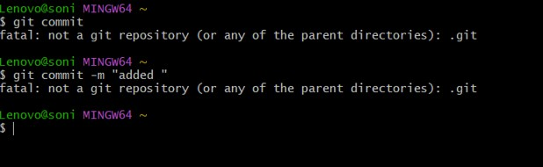

**Note ::** mode will changed : and All staged file ---> commit

files will again untracked mode and will unstaged

**git-Architecture-1 –**

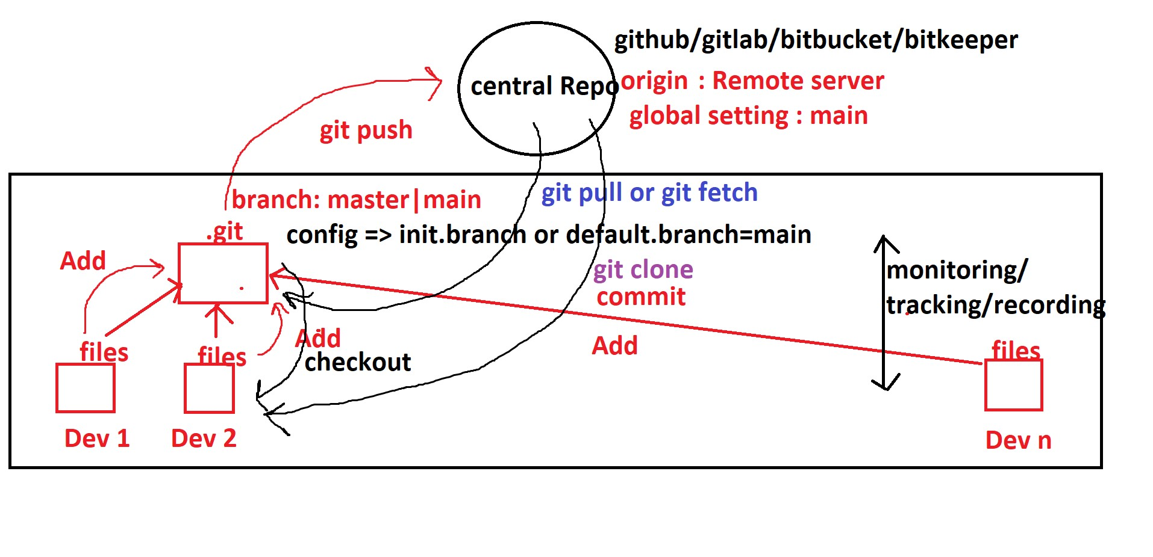**git-Architecture-2 –**

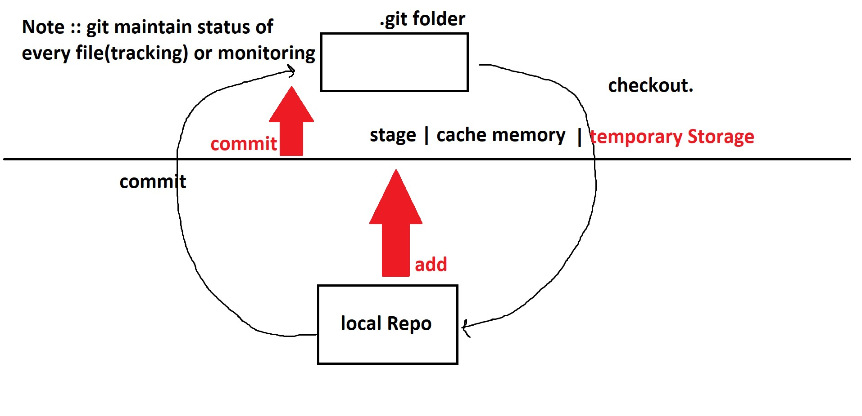

**Architecture-3** –

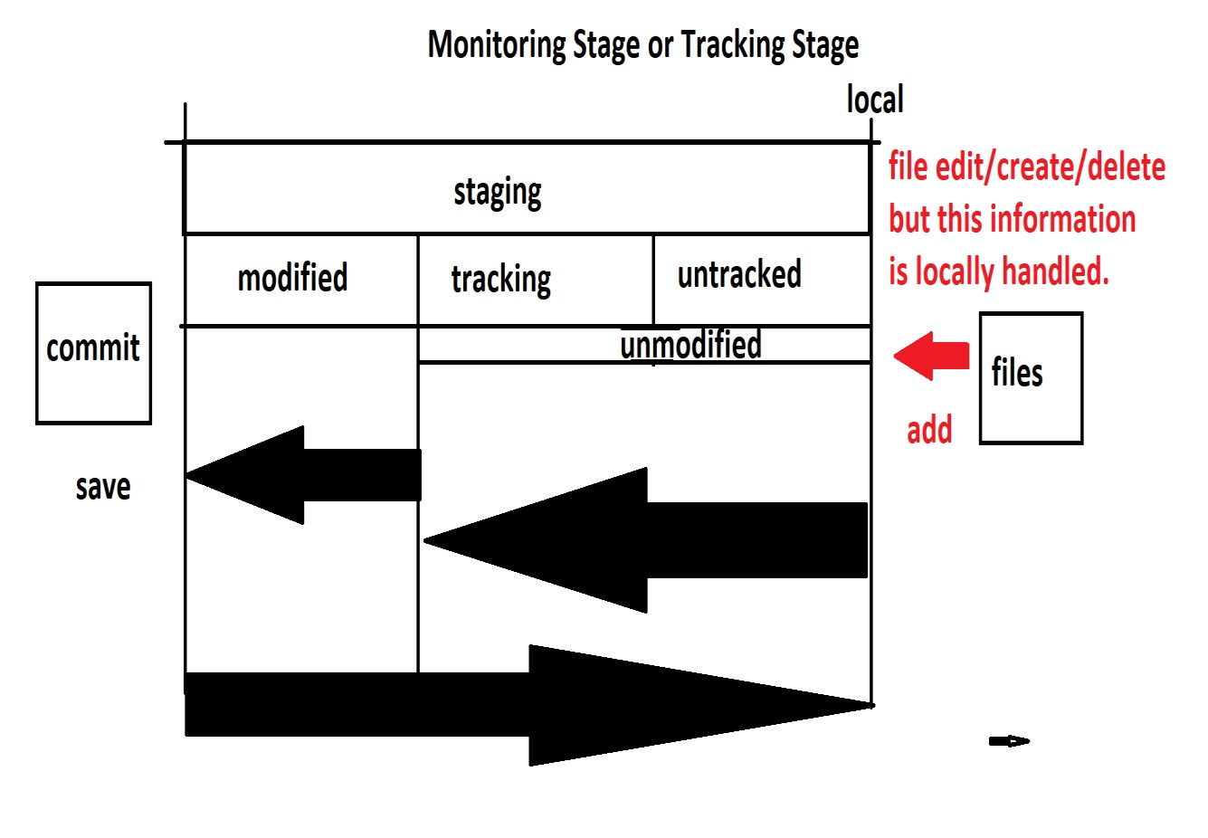

**Commit** –

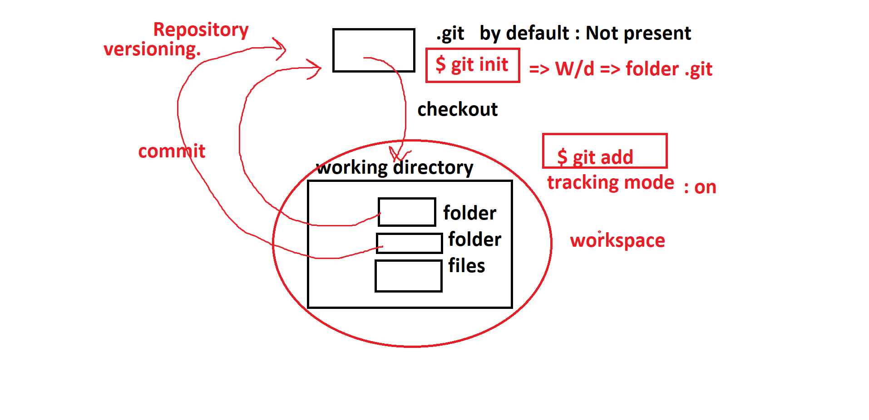

#### How to checkout:-

$ git checkout <file-name>

$ git checkout .

#### git branches :-

#### https://learngitbranching.js.org/

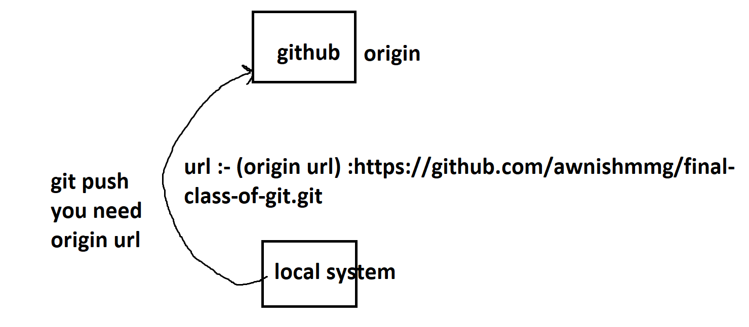

**Q1.** Which of the following is default branch of github

1.master (Correct)

2.test

3.awnish

4.production

5.None of the Above.

**Q2.** Which of the following is default branch of github

1.master

2.main (Correct)

3.awnish

4.production

5.None of the Above.

One Important Tools very very Popular (TCS,wipro,....infosis,...)

**PMS :** is used follow the Organisation workflow in SDLC.

JIRA paid software (PMS | 1800 Software)

OpenProject open source (PMS | 1 Software)

**Software** => SDLC (Software Developement Life Cycle) => Organisation

S/W Company

1. service based.

2. product based.

#### Brief Introduction About Agile and SDLC

2 weeks => 14 Days => sprint : (time period of project in 1 Sprint)

10 Days => scrum

1 week => 5 days scrum call.

#### Process of Sprint

1. Sprint Planning or grooming

2. 1-Week-Scrum-Review Meeting on Daily Basis or weekly Basis (most of the cases)

**1-day** Daily Stand Up Scrum (planning|Internal-

Demo|Retro) |DSR(Daily Status Report)

2-day Daily Stand Up Scrum

3-day Daily Stand Up Scrum

4-day Daily Stand Up Scrum

5-day Daily Stand Up Scrum Review Meeting fix

1. Monday-Demo Internal or Restrospection (Retro meeting)
   1. stop doing

2. keep doing

3. start doing

4.Friday Release or Client Demo

**For More Information Visit :-**

https://hygger.io/blog/what-is-scrum-lifecycle/

#### Converting Scrum to Git:-

_______________________**Scrum 1**__________________________

Daily Stand Up

$ git clone or git pull 07-Nov-2022

DSR or Review Daily

$ git commit git push : code Review

merge master

________________________ Scrum 1 _________________________

**Connect with JIRa**

**Task No** : TN -1 Kaif

#### Project XYZ

1. TN-0 master : License

2. TN-1(Ekarsh) : Create Index.html

3. TN-2(Akash): Create About.html

1. TN-3(Sheshank): Create Contact.html
2. TN-4(Satyam): Created Login.html

6 TN-5(vijayshekhar): Created Dashboard.html

7. TN-6 (Harsh) : Create Test Report

**Agile-scrum-cycle** –

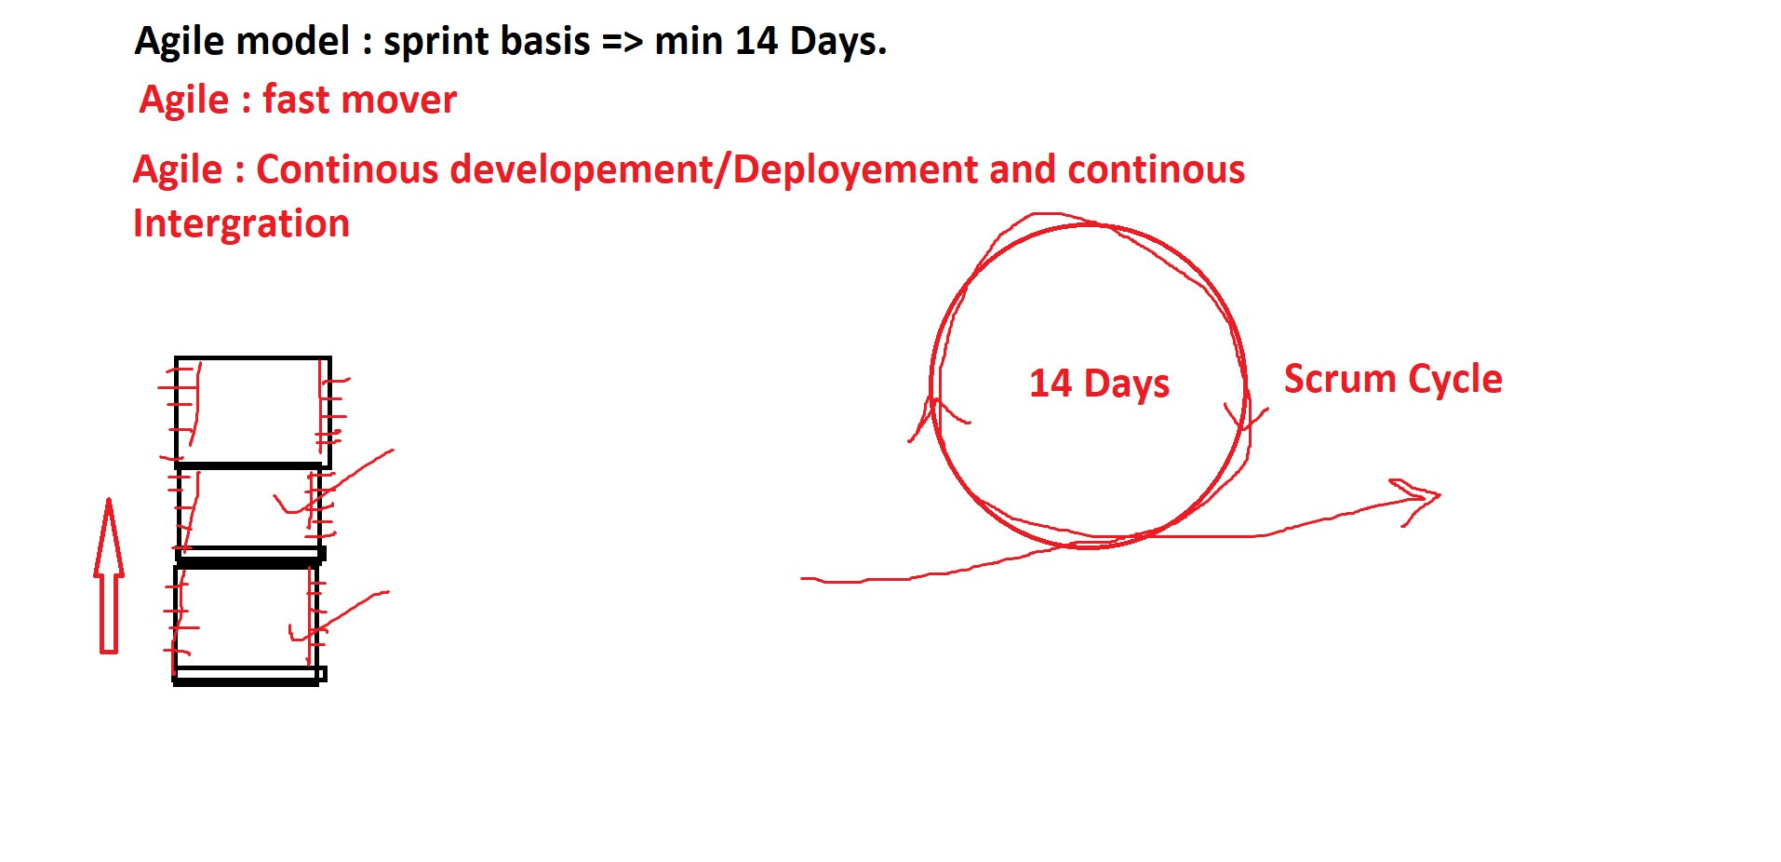

**scrum-diagram –**

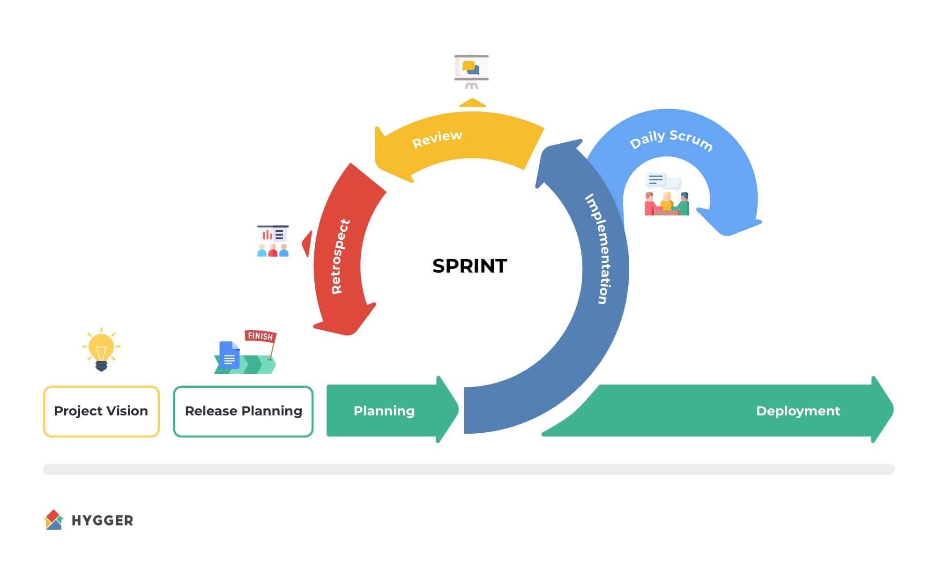

**Water-fall-model –**

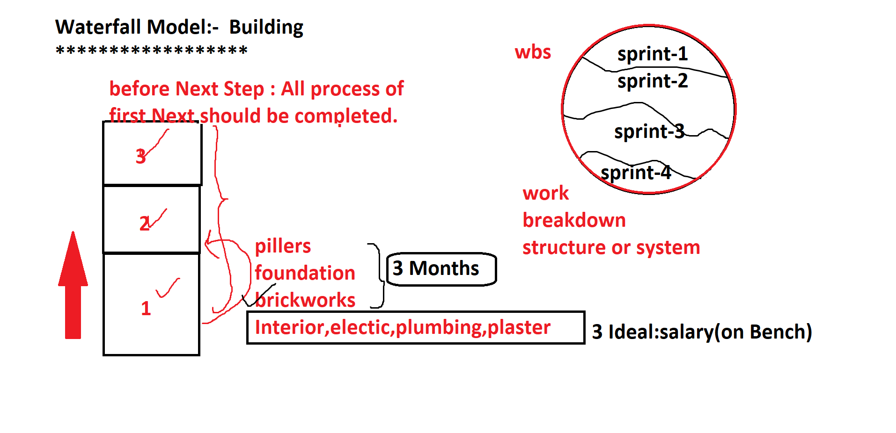

**Jira-tool** –

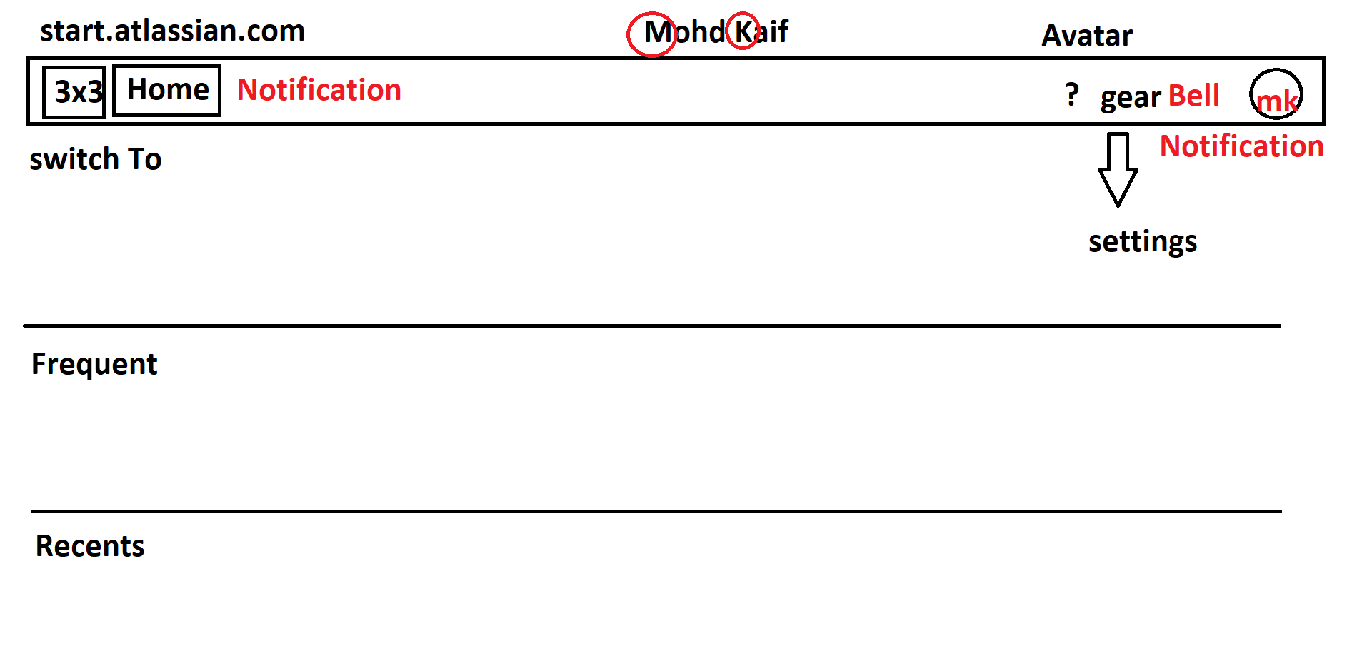

**git :** username and useremail(Author) : Jira Ticket Assigned Name.

**commit :** Date and time

Date and time ----> scrum date Jira 8 Hours

pull Request and Push

#### How to see branch:-

git branch

*master | current branch

#### How to get Commit Information:-

$ git log

#### How to create a new branch:-

$ git branch <any-new-branch>

#### How to change the branch:-

$ git checkout <branch-name>

**Note ::** Merging can take place only by two ways

1.checkout from master and merge from master (easy) to any branch

2. checkout with latest commit on the child branch detach the head and merge with child branch (difficult and confusing).

**Note ::** Never forget to finally commit.

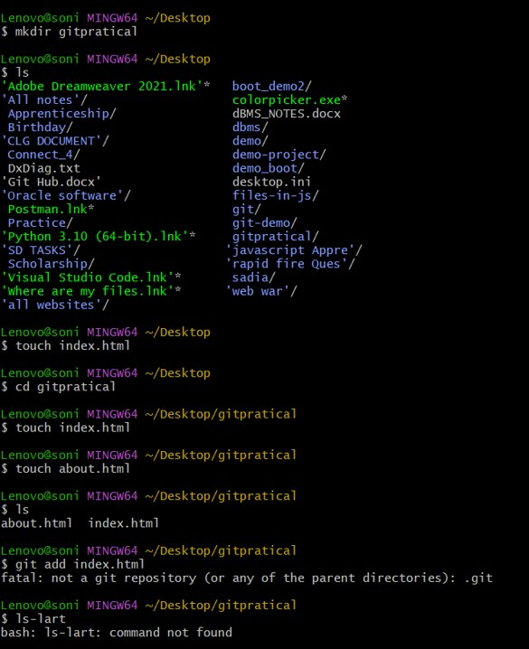

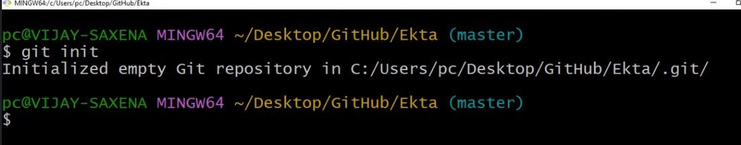

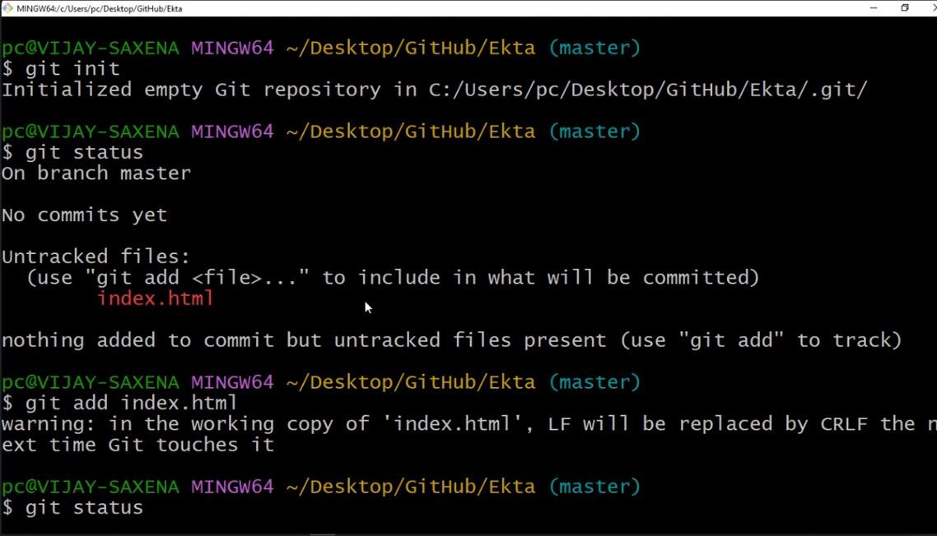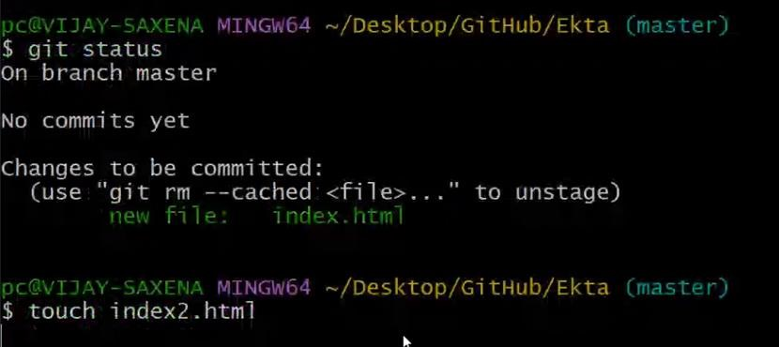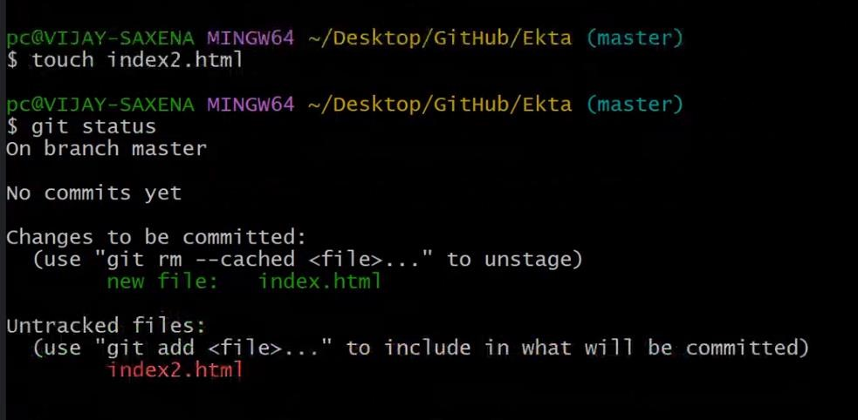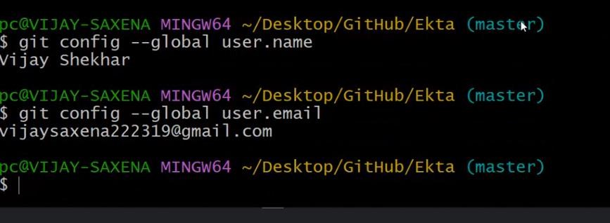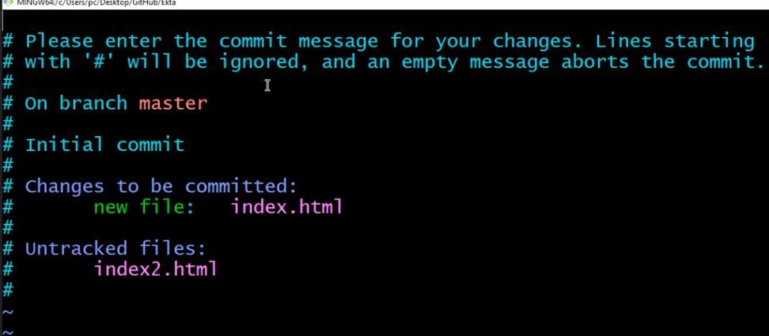

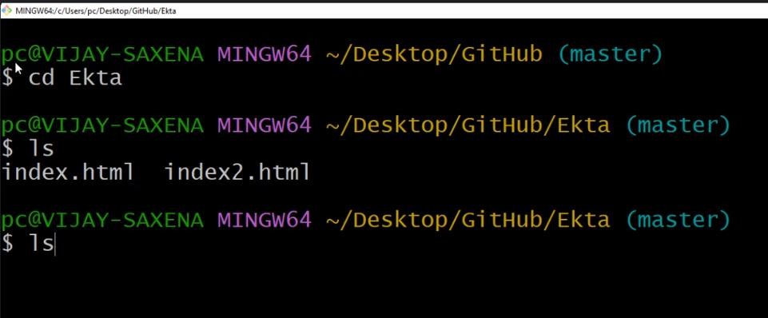

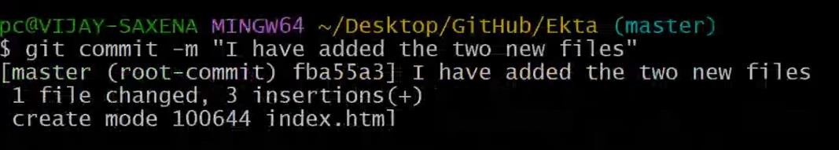

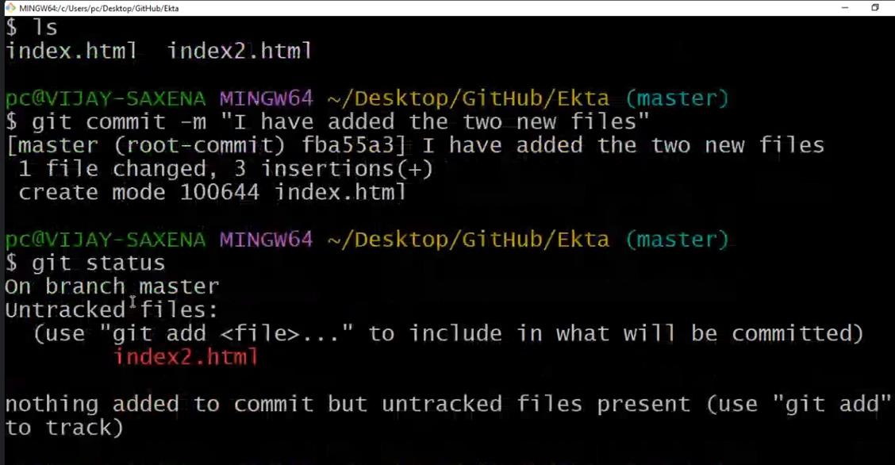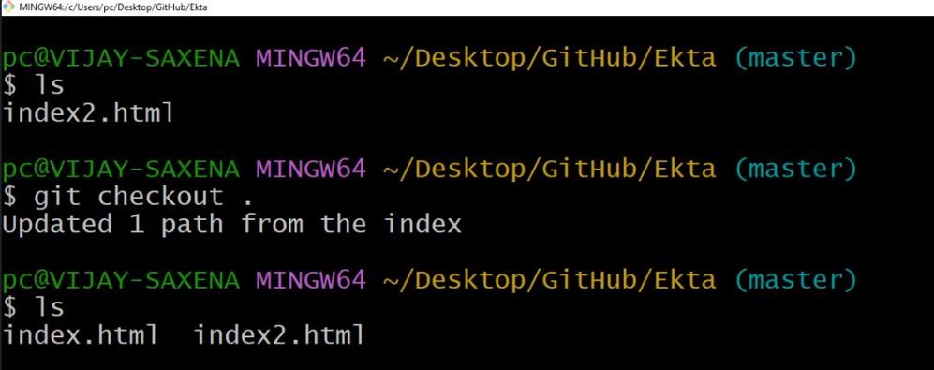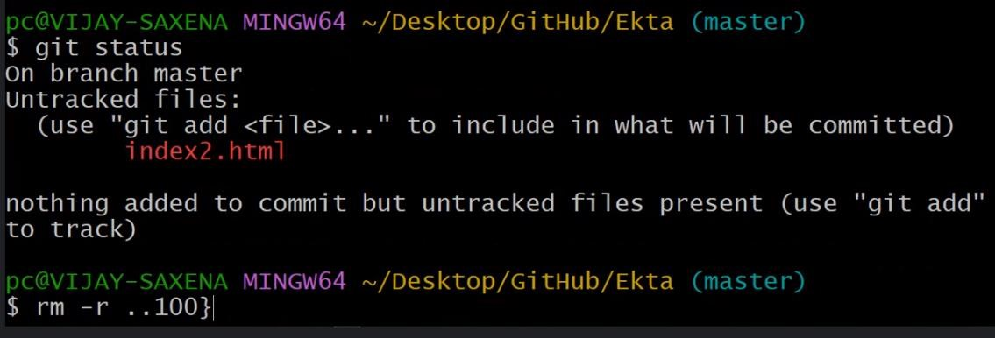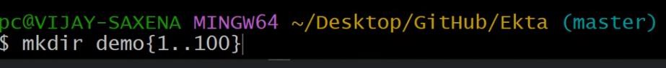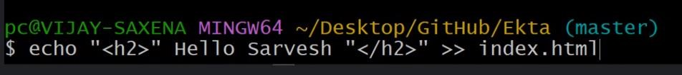

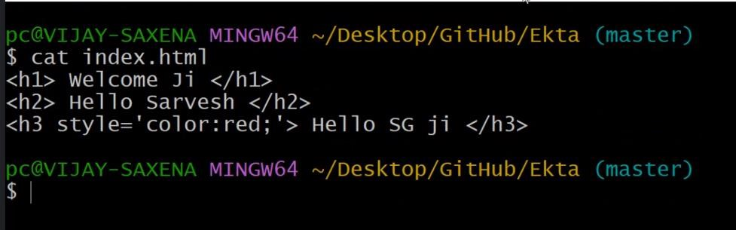

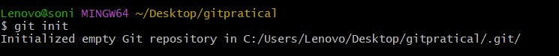

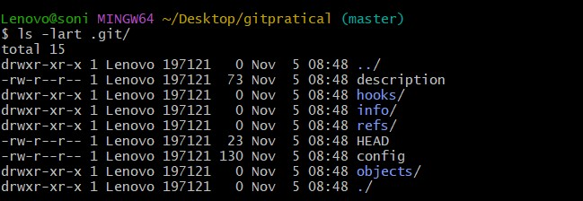



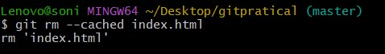

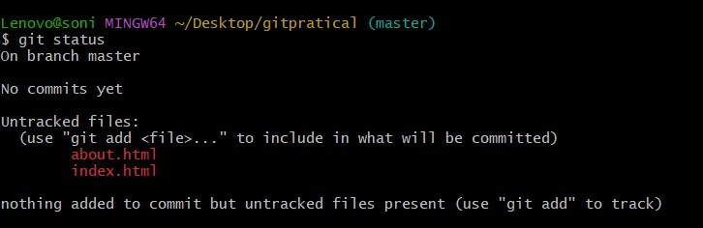

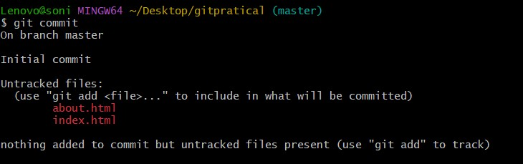

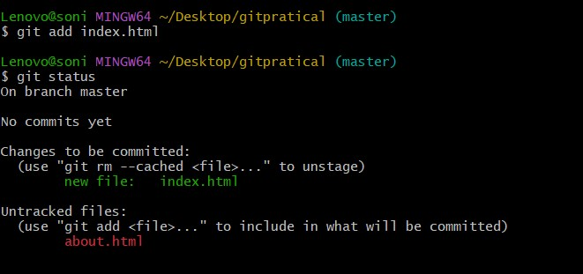

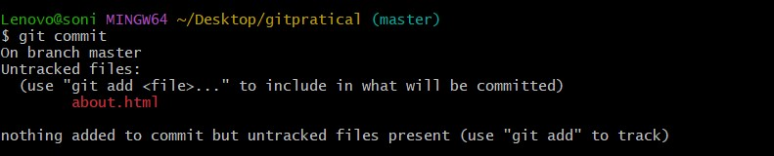

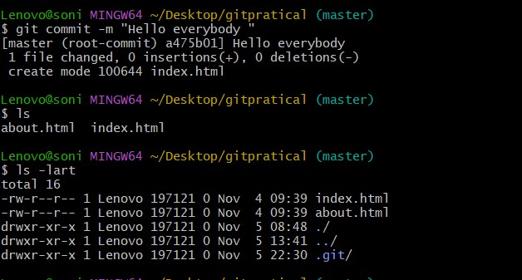

**How to merge the code from one branch to another:-**

#### steps are :-

1. checkout to master branch
2. check for the head using git log ( Head-> master)

**Note::** Head is recent commit in a branch

1. start merge using command

$ git merge <branch-name> at master branch **4.** After that Auto-merge will happen

check for the merge conflicts

1. once merge conflicts is solved put all the files to the stage from master branch.
2. and finally commit, Now

Head (Recent commit CommitId of Another branch) will be

merged for Head(Recent commit commitId of Master Branch)

**How to merge :-**

$ git checkout master

$ git log

$ press q to exit from git log is done

$ git merge <branch-name>

$ if not Error Auto-merge will happen

$ git add .

$ git commit -m "Finally Merged with any branch-name "

#### How stop/kill/pause merge :-

**************************************

$ git merge --abort

#### How to Resolve the Conflicts :-

****************************************

merge conflicts arises when, two coders code at branches but write the different code on same line number,

then git cannot decide which line to keep and which to delete,

hence there arises a conflict.

hence it will organise the code in order of commit with is

Ahead another commit

#### when you open a conflict file:- (index.html or about.html)

*******************************************************************

<<<<<<<<<<<<<< HEAD

This is first line code

=============================

This is second line code

<<<<<<<<<<<<< Prashant

hence in order to resolve the conflicts, we need to solve or remove these lines.

#### after cleaning

1| This is first line code

2| This is second line code

$ git add .

$ git commit -m "code cleaned and Now ready to merge"

[new commitId] merged with <new-commitId>

#### difference B/w git branch and git branch --all

**************************************

1. **git branch :** show all local branches
2. **Remote(cloud => github)** git branch --all : local + cloud

server branches.

#### Help of git:-

***********

$ git help <topic-name>

#### Eg :-

$ git help branch

$ git branch -d <branch-name>

#### How to push, code to Github

**************************

1. working with .gitignore
2. touch .gitignore

Add the file-name and folder-names you dont want to

sent to server.

1. Decide which branch code you want to send
2. Update 2021, Older time, git login from system

username and password

**latest time** :- username

**personalised token** :- use token instead of password.

#### How to generate token

1. login github
2. global settings
3. developer settings
4. peronalise Token

**simple Token(classic)** => Title => generate Token => Copy

save the token.

Customise Token

1. Open Credential Manager
   1. window credentials
   2. git remove all password and username.

1. create a Repo private/public

#### How to see origin url

*******************

$ git remote -v

1. **fetch version :** url must exist then only push possible.
2. **push version :** url must exist then only push possible.

#### How to Add url :-

**************

$ git remote add origin <url-copy-paste>

**for eg:-**

$ git remote add origin https://github.com/awnishmmg/finalclass-of-git.git

$ git remote -v

**(fetch) :** https://github.com/awnishmmg/final-class-of-git.git

**(push) :** https://github.com/awnishmmg/final-class-of-git.git

#### Finally push the code

**********************

$ git push origin <branch-name>

#### or

**$ git push -f origin <branch-name>**

**branch :**  master

dev

tester

$ git push -f origin master

$ git push -f origin dev

$ git push -f origin tester

**[ SELF LEARNING ….]**

#### Git Repository cmd :--

1. mkdir foldername --------> create folder
2. cd --------> change directory
3. git touch filename --------> create new file (index.html ,

about.html)

1. git init --------> for file initialization
2. ls -------->
3. ls -lart --------> for check all directory files
4. git add filename --------> file in traking mode

git branch

git branch soni

git checkout soni -----> working /swiching account

git log

git add. ----> add all file current directory

cat filename

cat index.html -------->show all code

git checkout master

git merge

git --abort ----> stop the merging

git commit -m "....."

**Two Types**

***************

1. Ansi Standard

1. Natural

1. Equi-join
2. Non-Join
3. Normal Join (inner Join)

2. Non Ansi Standard

i.) Outer Joins

a) Left

b) right

c) Full Outer Joins

ii.) self joins

iii.) cartesian Product (cross Join)

Insert into tablename values('','','','');

Insert into values('','','','');

tablename : college

Insert into college values('','','','');

insert college values('','','','');

A : Atomicity

C : consistency

I : Isolated

D : Durability

Atoms consit of insolated Duracel.

**JIRA**

**Jira :-**

******

1. Pms Project management

2. it is product of Atlassian (Australian Company)

3. 60,000 Teams and world Wide use

4. it is Running on Cloud Server

5. Jira

1. user => for every new user -> sub-domain create

2. Team(Organisation|group) -> sub-domain create

**Ex:-**

https://[shankar].atlassian.net(com)

|

username/organisation-name

Organisation name : infosis

https://infosis.atlassian.net(com)

6. Jira is a paid Software

7. Jira was launched in 2002

8. Jira is a Product

**Marketplace of Jira :-**

**Marketplace :** product sell but demo is possible for free

Jira has 1000+ paid and free software

**Software Categories**:-

free : always free

paid : always paid

propariaty s/w : paid some time free or demo (15 days or 30 days)

**products of Jira**:-

1. Jira Confluence

2. JiraOps (Administration) : opsgenie

3. Jira Service Management : Others like Finance,legal, salary, Support

etc Jira Service Management.

**Jira Confluence** : All documents related to SDLC like SRS,licensing

Audit, security Audit

**JiraOps :** Administration level work, user create, user delete, user invite, user block.(Opsgenie)

**Integration Jira <-------Connect---------> GitHUB (marketplace)**

**Important links to Jira**:-

id.atlassian.com : Jira Login Mode => Already Login => Dashboard

**Jira Starting Mode**

git

start.atlassian.com

**How to upload a file using git bash –**

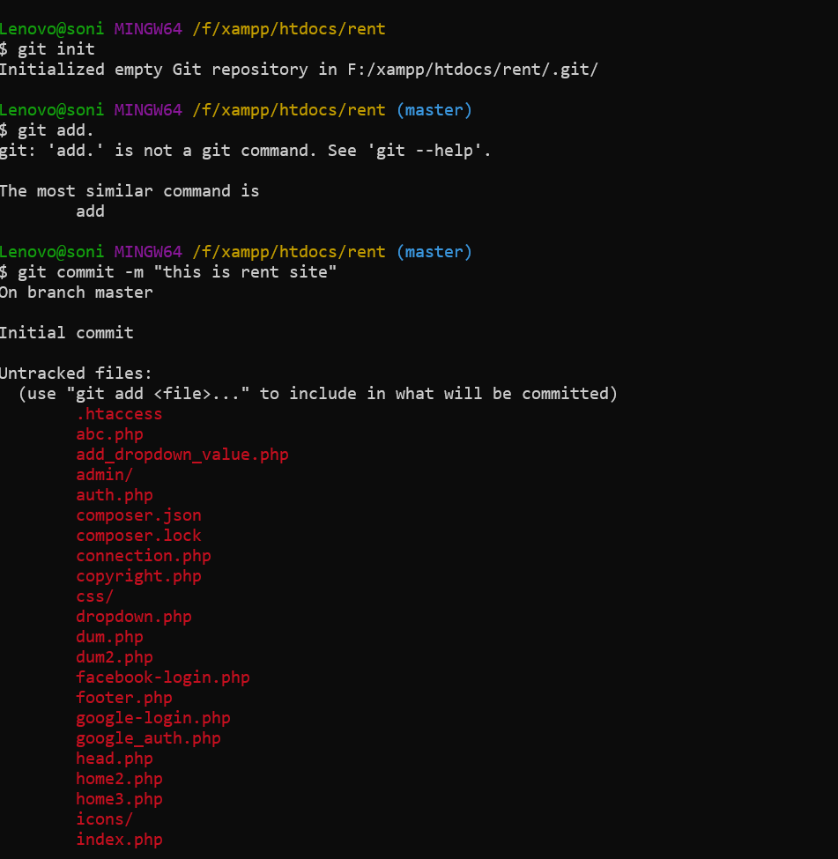

🡪

$ git init

🡪

$ git add.

🡪

$ git commit -m "this is rent site"

🡪

$ git remote add origin “link”

* How to link
* Go to github and copy the link

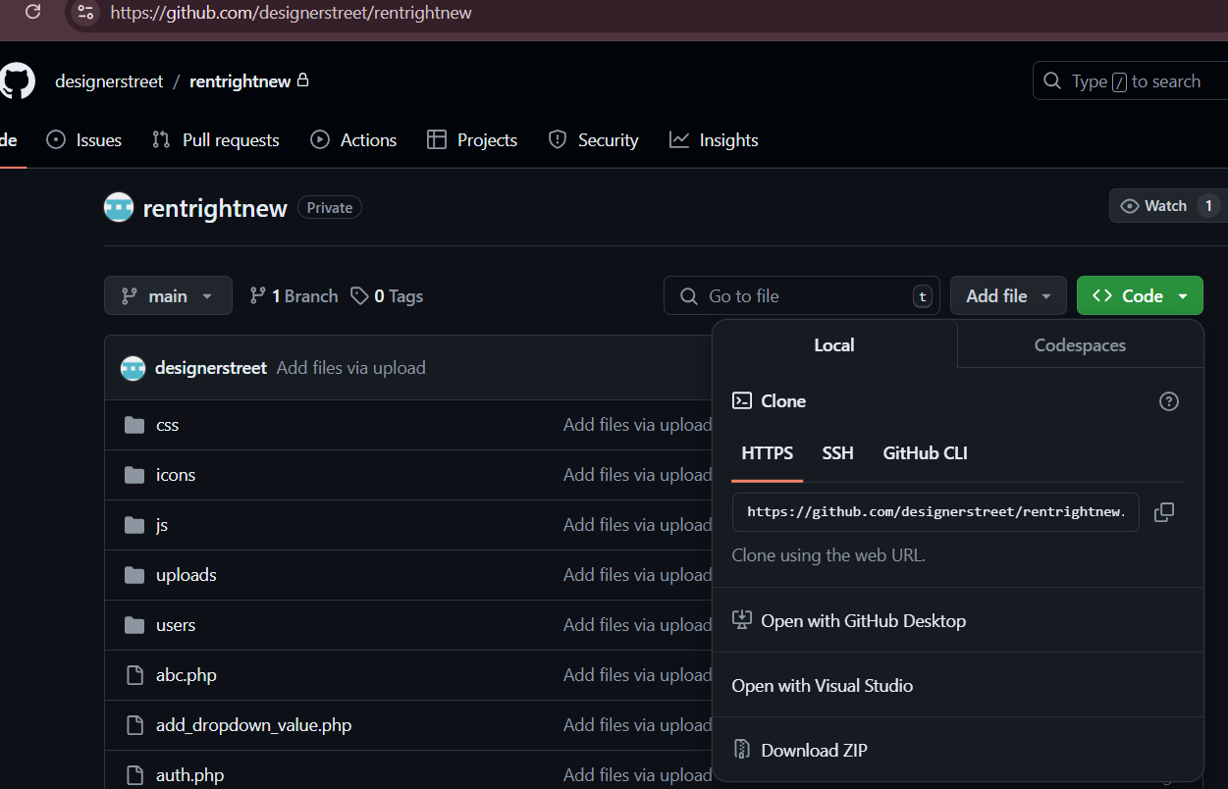

Git

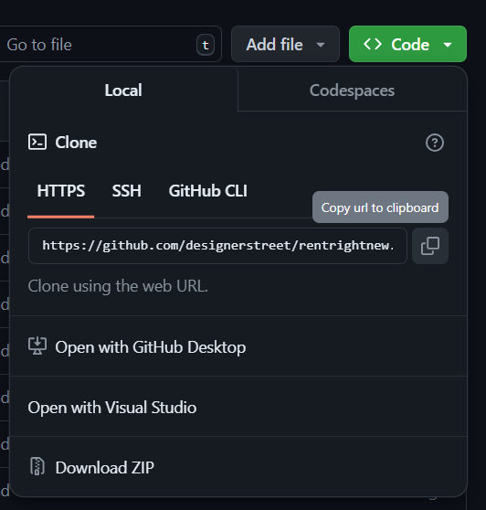

* <https://github.com/designerstreet/rentrightnew.git>
* 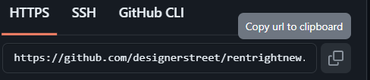

🡪 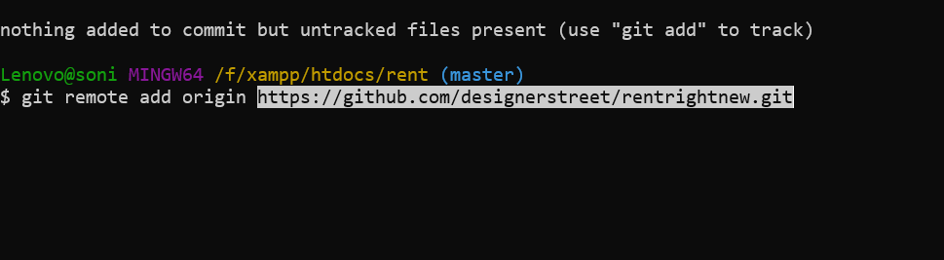

🡪

$ git push -u origin master

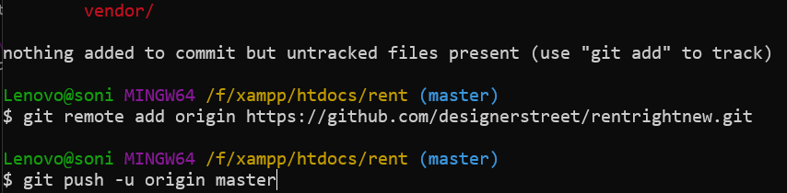

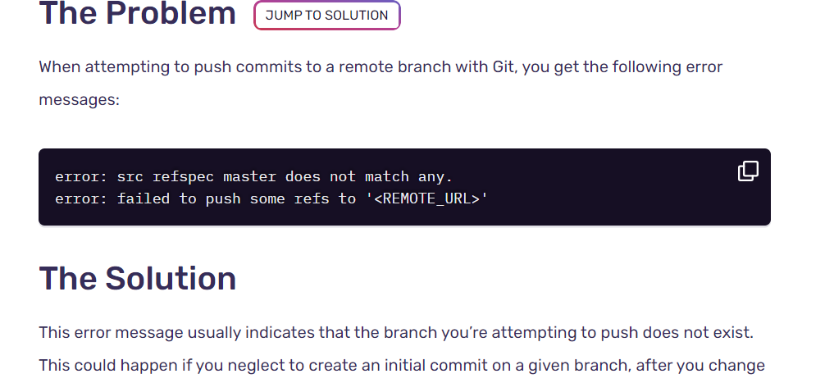

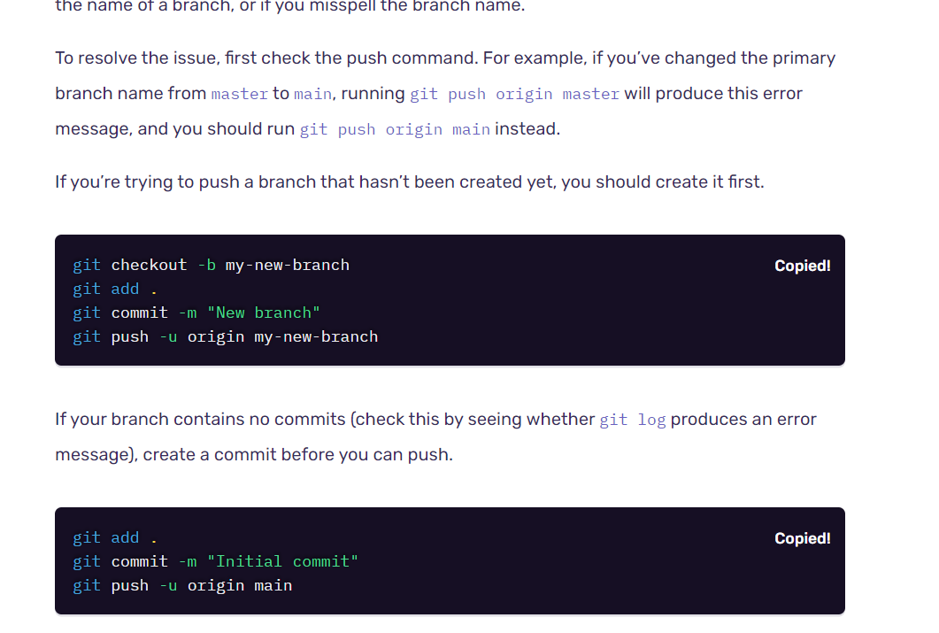

🡪

git checkout -b my-new-branch

git add .

git commit -m "New branch"

git push -u origin my-new-branch

🡪

git add.

git commit -m "Initial commit"

git push -u origin main

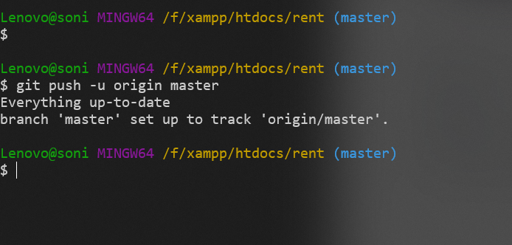

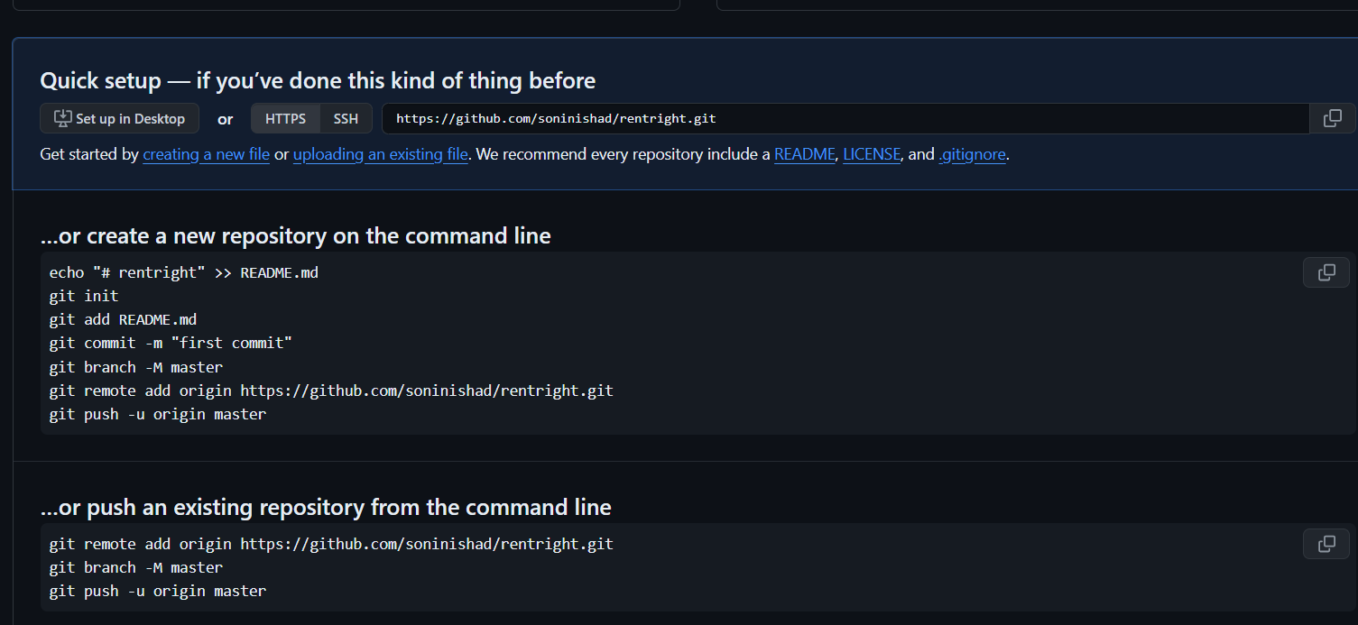

🡪

echo "# rentright" >> README.md

git init

git add README.md

git commit -m "first commit"

git branch -M master

git remote add origin https://github.com/soninishad/rentright.git

git push -u origin master

🡪

git remote add origin https://github.com/soninishad/rentright.git

git branch -M master

git push -u origin master

How to change the path of Git Bash ---- using command line—

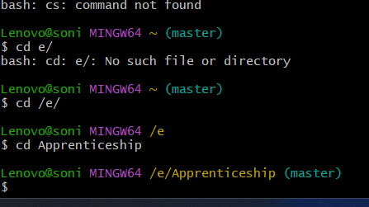

* cd /e/
* cd Apprenticeship

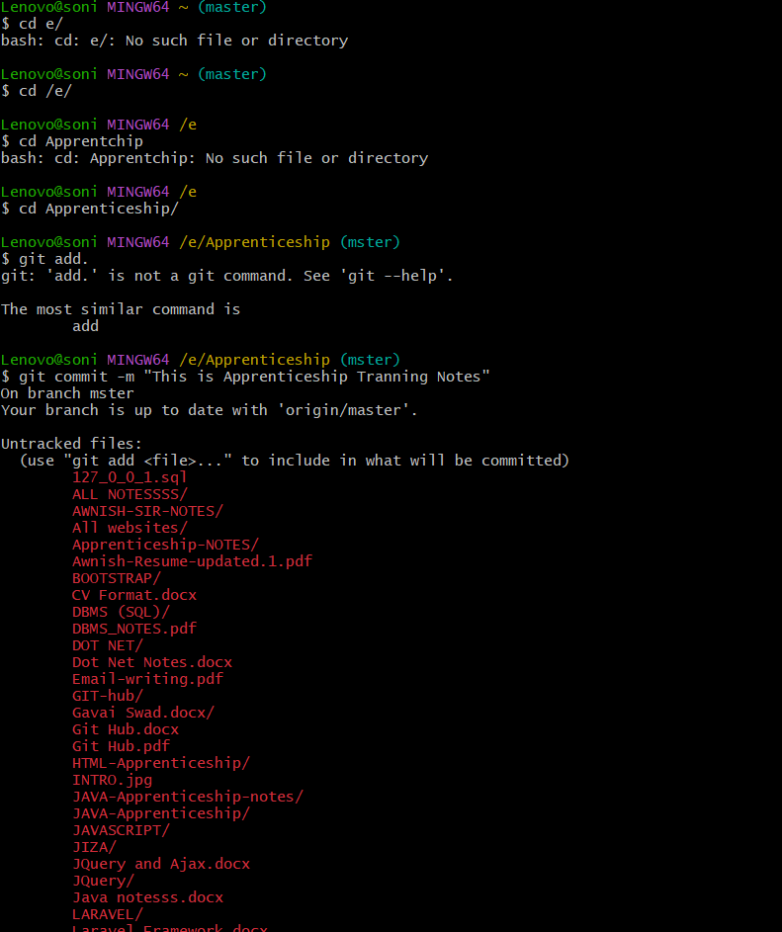

How to chnge git branch name – ( main 🡪 master ) convert

git checkout -b <new-branch-name>

* git checkout -b master

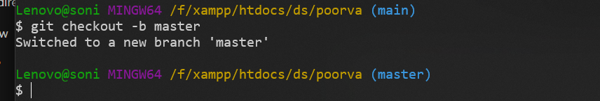

🡺

* git fetch origin
* git pull origin main
* git add <file_with_conflict>
* git commit -m "Resolved merge conflicts"
* git push origin main
* **git push origin main --force**

